Session 11:
Task 1:
Syntax used as follows:
Create database mydb;
Use mydb;

Create table Restuarants
(Name varchar (30),
Ratings Int);
Select * from Restuarants;

Insert into restuarants
values ('Tasty_Bites',5),
('Urban_Kitchen', 7),
('Royal_Dine', 9),
('Green_Leaf', 4),
('The_Food Hub', 3),
('Masala_House', 6),
('Café_Delight', 3),
('Punjabi_Rasoi', 10);

Select
Avg(ratings) from restuarants;

SELECT Name, Ratings
FROM restuarants
WHERE Ratings > (
SELECT AVG(Ratings)
FROM restuarants
);

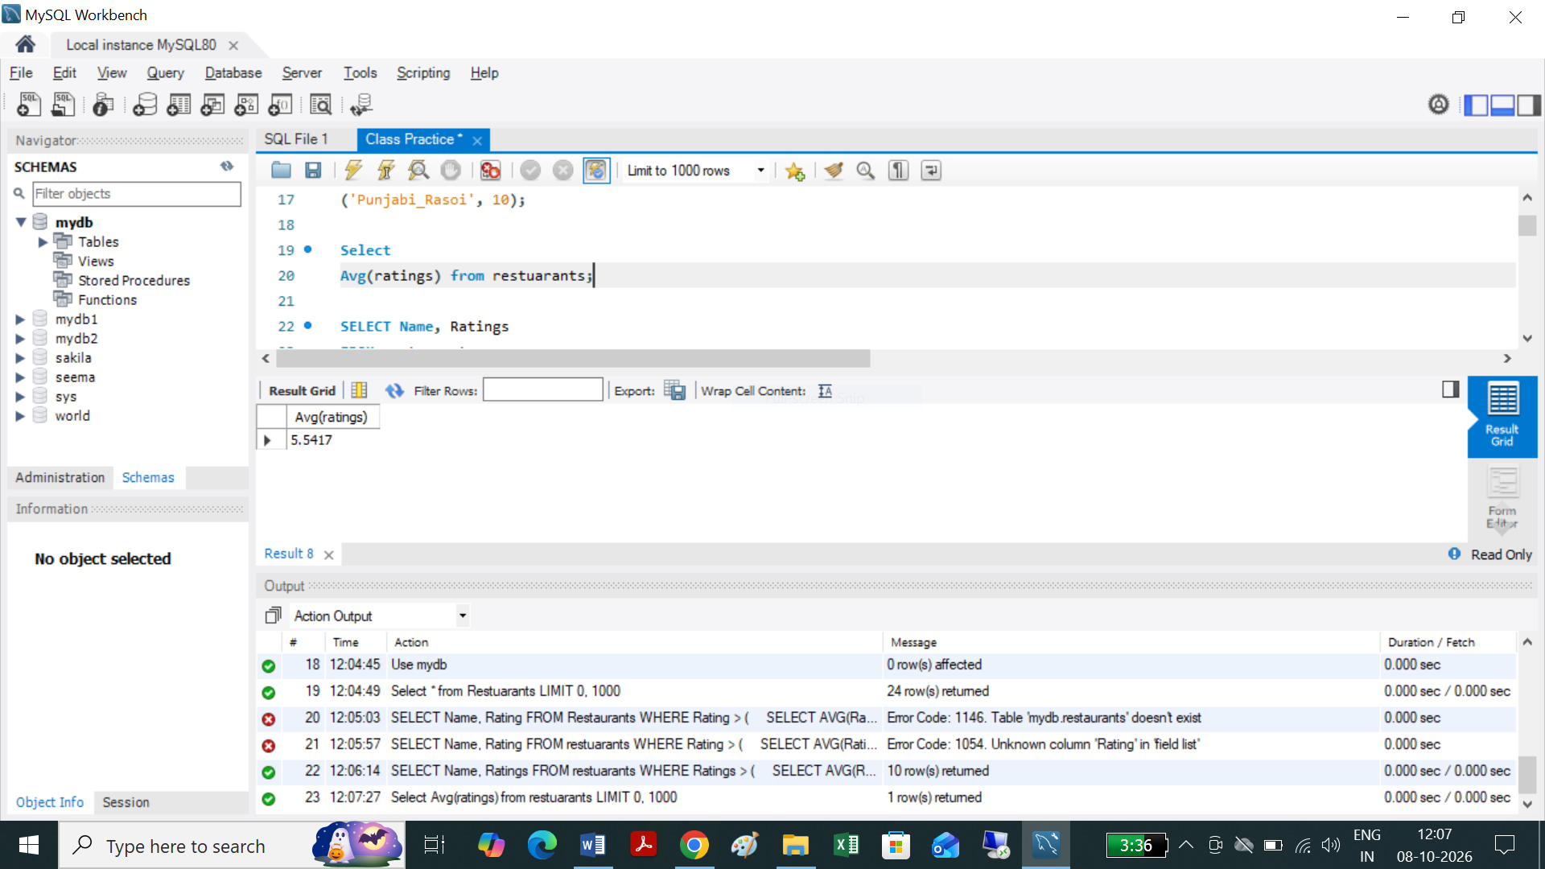

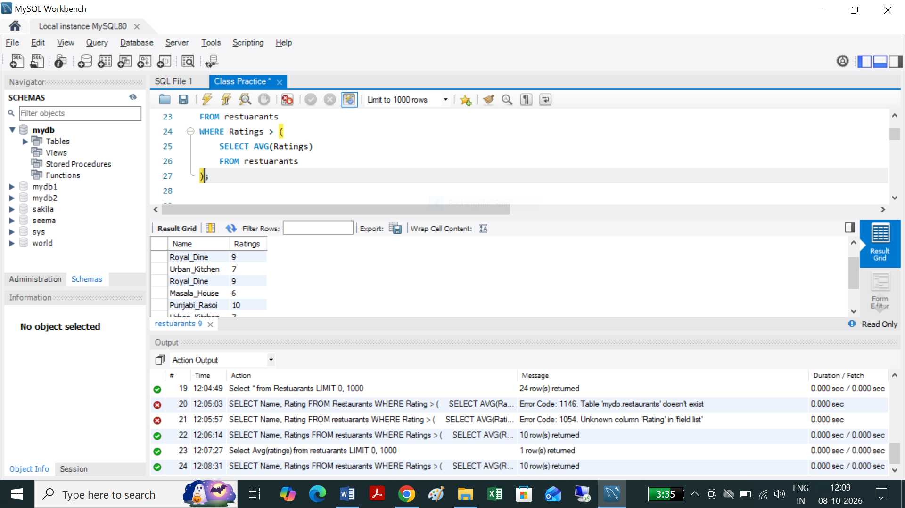
The subquery calculates the average rating of all restaurants, and the outer query displays only restaurants whose rating is higher than that average.
For this sample data, the average rating is 5.5, so restaurants with ratings above 5.5 will be displayed.

Task 2:



Create table Products
(product_id INT,
Name Varchar(100),
price Decimal (10,2),
Category Varchar (50));

Select * from Products;

Insert into Products (Product_id, Name, Price , Category)
Values
(101, 'iPhone 14', 69999, 'Mobiles'),
(102, 'Samsung Galaxy S23', 74999, 'Mobiles'),
(103, 'OnePlus 11', 56999, 'Mobiles'),
(104, 'HP Laptop', 54999, 'Laptops'),
(105, 'Dell Inspiron', 62999, 'Laptops'),
(106, 'Lenovo IdeaPad', 48999, 'Laptops'),
(107, 'Boat Headphones', 1999, 'Audio'),
(108, 'Sony Headphones', 4999, 'Audio'),
(109, 'JBL Earbuds', 2999, 'Audio'),
(110, 'Nike Shoes', 5999, 'Footwear'),
(111, 'Adidas Shoes', 4999, 'Footwear');
Select
Name, Avg(Price),Category from Products group by Name, Category;

SELECT
p.name,
p.price,
p.category,
(
SELECT AVG(p2.price)
FROM Products p2
WHERE p2.category = p.category
) AS average_category_price
FROM Products p;

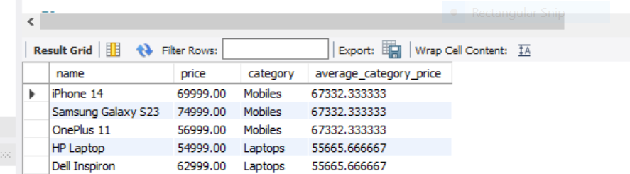

Task 3:
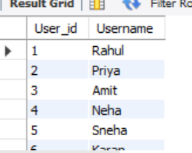
Select * from Users;
Create table Users
(User_id int,
Username Varchar (30));

Insert into Users
VALUES
(1,"Rahul"),
(2,"Priya"),
(3,"Amit"),
(4,"Neha"),
(5,"Sneha"),
(6,"Karan");

select * from users;

select * from Playlists;
Create Table Playlists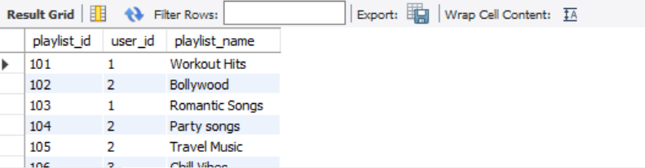

(playlist_id int,
user_id int,
playlist_name varchar (30));

Insert into Playlists
VALUES (101,1,"Workout Hits"),
(102,2,"Bollywood"),
(103,1,"Romantic Songs"),
(104, 2, "Party songs"),
(105, 2, "Travel Music"),
(106,3,"Chill Vibes"),
(107,3, "Morning music"),
(108,3,"Study Music"),
(109,3,"Favorites"),
(110,4,"Bollywood Hits"),
(111,5,"Relaxing music"),
(112,5,"Punjabi songs"),
(113,6,"Old Classics");
select * from Playlists;
SELECT
u.username,
p.playlist_count
FROM Users u
JOIN (
SELECT
user_id,
COUNT(*) AS playlist_count
FROM Playlists
GROUP BY user_id
) p
ON u.user_id = p.user_id
WHERE p.playlist_count > (
SELECT AVG(playlist_count)
FROM (
SELECT
user_id,
COUNT(*) AS playlist_count
FROM Playlists
GROUP BY user_id
) AS playlist_counts
);


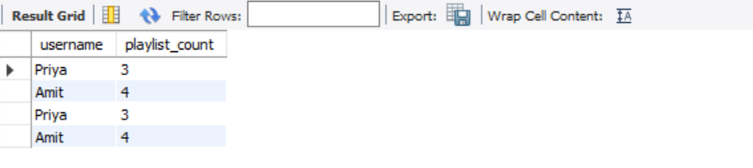

Task 4:
use mydb;
Select * from Orders;
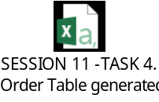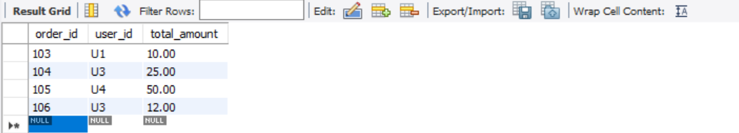
CREATE TABLE Orders
(order_id INT PRIMARY KEY,
user_id VARCHAR(50) NOT NULL,
total_amount DECIMAL(10, 2) NOT NULL
);

INSERT INTO Orders (order _id, user _id, total _amount)
VALUES
(101, 'U1', 15.00),
(102, 'U2', 40.00),
(103, 'U1', 10.00),
(104, 'U3', 25.00),
(105, 'U4', 50.00),
(106, 'U3', 12.00);

SELECT DISTINCT user_id
FROM Orders
WHERE total_amount > (
SELECT AVG(total_amount)
FROM Orders
);

